**Analysis of the currency pair CAD/EUR – 4H using the single stock system**

**"Integral calculations"**

Goal: Finding the relationship between past and future markets in a reverse chart and calculating and calibrating the sequence in the future based on the available data, leading to obtaining the market high in that area. According to our assumptions and calculations based on the training, the price chart in the future market should touch and collide with its close range and reverse from that point.

Here are the steps to get the job done in a nutshell, following a fixed set of principles:

1. Choose two different periods where the price changes in the second period are almost twice as much as in the first period.

2. Name the first-period Y region and the second-period Z region and place them in two boxes. The boxes are drawn to align the top and bottom edges with the respective areas' peaks and valleys.

3. Determine the candles' high, low, and close for Y and Z periods.

4. Write the Stoch relations for two periods, Y and Z.

Stochastic: $k=\frac{C-L_{n}}{H_{n}- L_{n}}$

C: Close price of the last candle of the period

$L_{n}:$ low period

$H_{n}:$ High period

5- We calculate the coefficient of variation or the error value of 1ZT.

After calculating the stock formula, from the differences between two regions or two periods, we get the amount of error in the system, which we call the "coefficient of variation," pay attention to the following formula; we get the standard x variable from the following equation:

$$Coefficient of variation=\frac{x+\left(Close changes of two periods\right)-(Low changes of two periods)}{ | \left(The difference High of two periods\right)-( The difference Low of two periods)|}$$

In other words, we have:

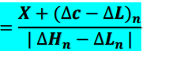

6. We plug the values into the error correction formula and use this equation to find two new packages that are valid and calibrated to package Y. One is the result package of adding x to Y, and the other is the result package from subtracting x from y close.

7. Then, we identify the new close of the candle and get all the upper steps for the closing position of the new candle.

8. We again determine the candle’s high, low, and close for two periods.

9. We name the new zones 1 and 2 and write the Stoch relations.

10- We recalculate the coefficient of variation of 2ZT.

11. Pug the values into the error correction formula to get a new package. From now on, we will move forward to find the new close.

We continue these calculations and form new boxes (regions) until we reach the end of the Z box. Then we extract the required values and use them in the final formula to get H.

**Implementation of work steps for successive calibration of the chart**

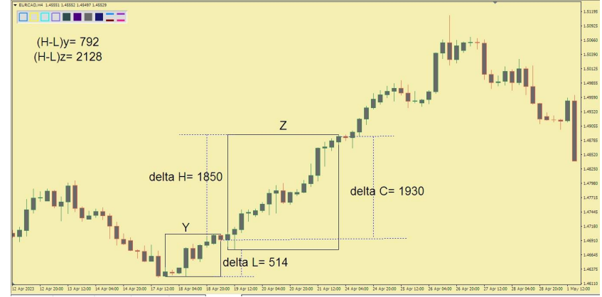First step: According to the price changes in the chart, we identify two areas. It is reminded that the price changes in the second area should be twice as much as the first area (or more). The desired areas are shown in the image below:

Now we need to perform calculations to reach an equilibrium x and form small zones relative to the close Y based on that. The differences that we need in the calculation process are shown in the above image.

First, we determine the formula for each zone. Therefore, we have:

$Py=\frac{X}{792}$

$Pz=\frac{X}{2128}$

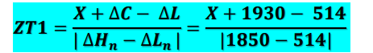Now, we obtain the formula for the coefficient of variation, as mentioned before:

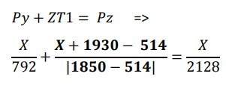Compared to the previous method, there is a difference in the formula to obtain x. In the last way, we set the sum of the procedure of area 2 with the coefficient of variation equal to the procedure of area 1. But in this method, the sum of the procedure of the Y area with the coefficient of change is similar to the procedure of the Z area:

Based on the above equation, X = -688 is obtained.

In the next step, we must subtract the number 688 with the close of the Y area. Close Y is equal to 146929. So 146929-688=142641 and 146929+688=141211 are obtained. Therefore, the cloze of areas 1 and 2 was obtained.

Note: When moving back and forth relative to the close Y to obtain new boxes (zones), it is possible that we cannot find a candle whose close exactly matches the numbers we have received. In this case, we move back and forth from the close Y. We consider the first candle that reaches our desired price and forms new boxes based on that. Now, the expected number may be aligned with the body or even the shadow of that candle.

Based on the obtained numbers, we form boxes 1 and 2. These boxes are shown in the picture below, along with the required information:

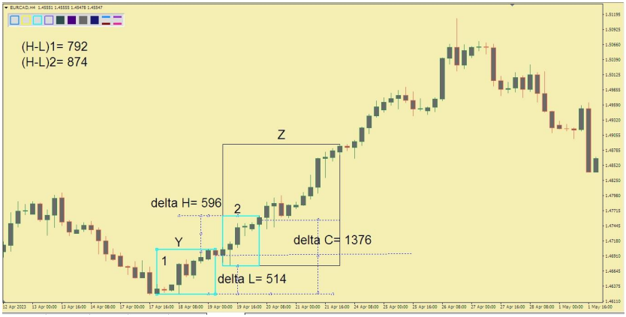

Please note that the actual closures of boxes 1 and 2 differ from what we obtained during the calculations shown in the above figure.

Again, we do the calculations as in the previous step:

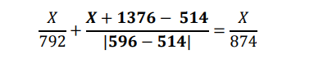

The result of the above equation is X=-854. As stated at the beginning of the journal, from this point on, we need to move forward and get the new box closed. The area’s closeness was two times 147617; we add the number 854, and the number 148471 is obtained. So the close box is three times this number, as you can see in the picture below:

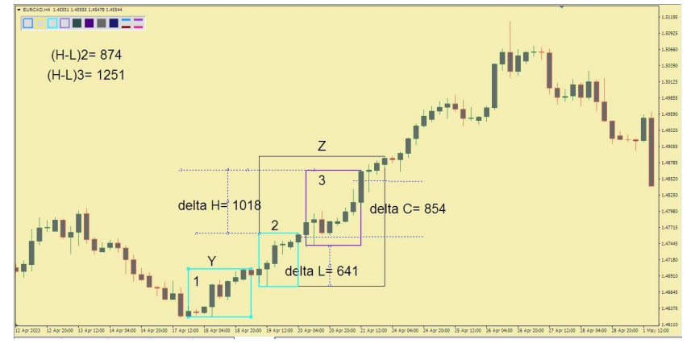

As before, we perform the calculations with the new data:

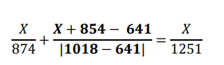

So, X = -188, as a result of the closed box, it is equal to 148659, which you can see in the picture below:

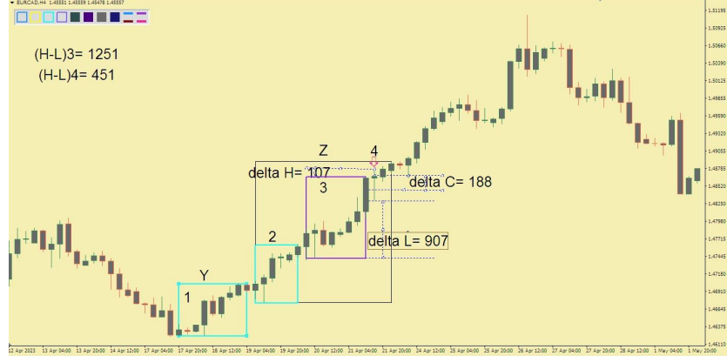

Again, we make calculations based on new data:



X=+377, as a result, the fifth box is equal to 148996.

According to the image below:

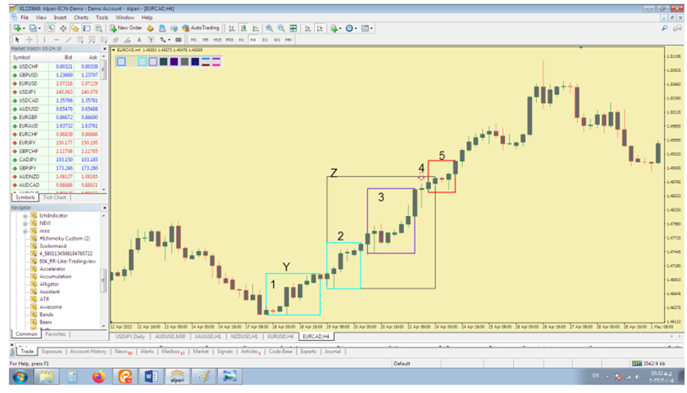

Second step: Now that we have reached the end of the Z box, the initial calibration ends. Based on that, we have to do some calculations to get the price return range.

The final calculations are based on the following formula:

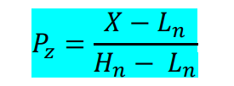

In this formula, besides H, there are two other unknowns. Therefore, we need to give a value to X and L to have an equation with only one unknown.

To find L, we need to find a low after the Z box and measure its distance from the origin of the coordinates (the low of the Y box). For X, we consider the distance from the ceiling of box 5 to the source of the coordinates.

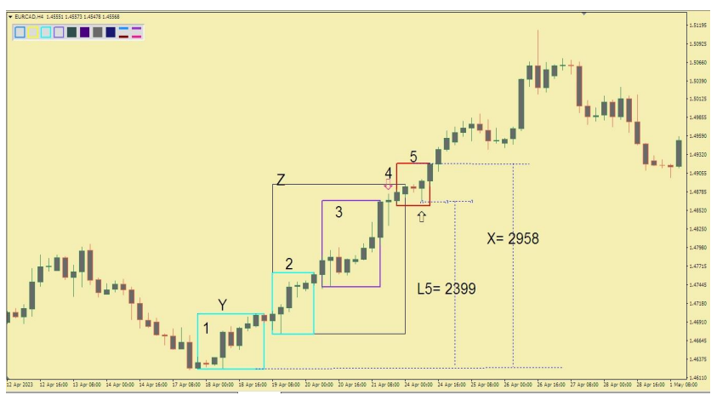

Now we put these numbers in the final formula:

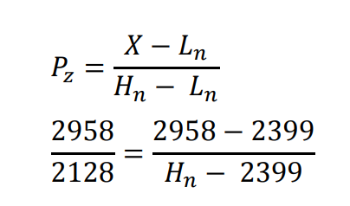

From solving the above equation, H = 2801 is obtained. We measure this number relative to the Y close, which can be seen in the image below:

But we must note that our calculations have some errors. Because a part of box five is removed from box Z. Therefore, we must include the specified error value: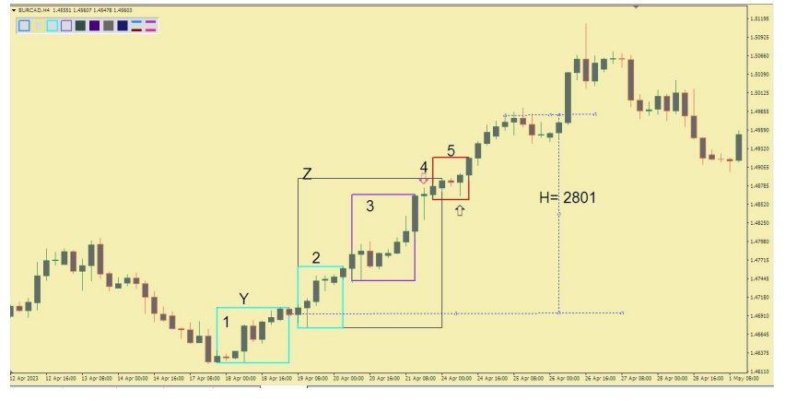

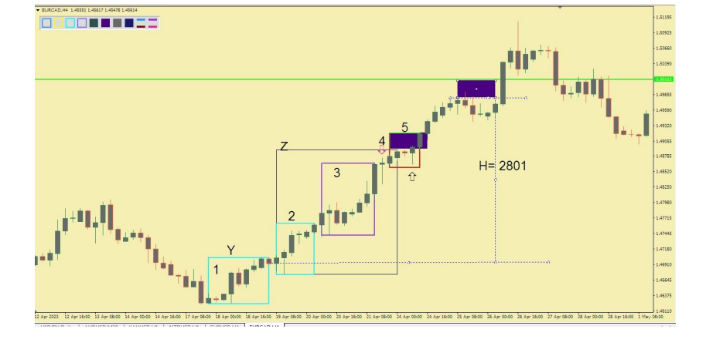

In the image above, the purple box is the error value we applied to the system.